**Introduction:**

The dataset called ‘Maternal Health Risk’, is based on the risk factors of maternal health in remote areas. In this project, we used the modified version of the ‘Maternal Health Risk’ dataset. The initial data has been collected from different hospitals, community clinics, and maternal health care providers in rural areas of Bangladesh through the IoT-based risk monitoring system. The initial dataset had 1013 instances and 7 attributes, but the modified version contains 200 instances with 9 attributes. The attributes are Age, Infection, Smoking, systolic blood pressure as SystolicBP, diastolic blood pressure as DiastolicBP, blood sugar as BS, body temperature as BodyTemp, HeartRate, and RiskLevel. All these are responsible and significant risk factors for maternal mortality, which is one of the main concerns of the SDGs (SDG 3: Good Health and Well-being) of the UN. This project aims to prepare data by applying a data science approach. Such steps include handling missing values, normalizing data scales, categorizing numerical attributes, and modifying outliers.

**Load Data:**

**Code:**

install.packages("readxl")

library(readxl)

mainData <- read_excel("E:/Coding Practice/Data Science/mid_project/maternal__mod.xlsx")

mainData

**Output:**

**Description:** Load Dataset to mainData

**Data Structure:**

**Code:**

num_instances <- nrow(mainData)

num_attributes <- ncol(mainData)

cat("Number of instances (rows):", num_instances, "\n")

cat("Number of Columns:", num_attributes, "\n")

str(mainData)

**Output:**

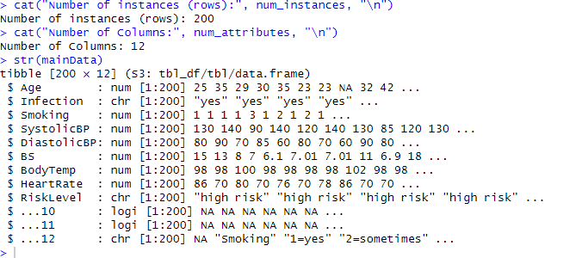

**Description:** To see the summary of the structure of data set. All the attributes with their type and their instances are shown here. The total number of instances is 200 and columns are 12. This str() function also shows that not all the columns are attributes. We need to process them further.

**Remove unnecessary columns:**

**Code:**

actualData <- mainData[, -c((num_attributes - 2):num_attributes)]

actualData

num_instances <- nrow(actualData)

num_attributes <- ncol(actualData)

cat("Number of instances (rows):", num_instances, "\n")

cat("Number of Attributes:", num_attributes, "\n")

**Output:**

**Description:** Last three columns were unnecessary, so we needed to remove them.

Number of instances: 200

Number of attributes: 9

Categorial Attributes are Infection and RiskLevel (also class attribute as it’s our target attribute).

**Unique Categories:**

**Code:**

unique(actualData$Infection)

unique(actualData$RiskLevel)

**Output:**

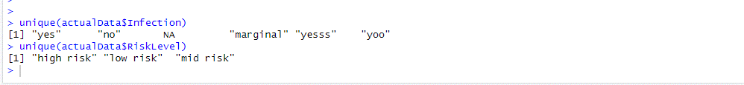

**Description:** Using unique functions we can find unique attributes. Here in Infection category, there are: "yes" , "no" ,NA ,"marginal" ,"yesss" , "yoo". NA is missing value we will take care of them in massing values section. "yesss","yoo" are invalid values of Infection attribute.

In RiskLevel attribute, there are: "high risk", "low risk", "mid risk". All are perfect and there are no invalid or missing values.

**Recover Invalid values:**

**Code:**

actualData$Infection <- ifelse(substr(tolower(actualData$Infection), 1, 1) == "y", "yes",

ifelse(substr(tolower(actualData$Infection), 1, 1) == "n", "no",

ifelse(substr(tolower(actualData$Infection), 1, 1) == "m", "moderate",

NA)))

unique(actualData$Infection)

**Output:**

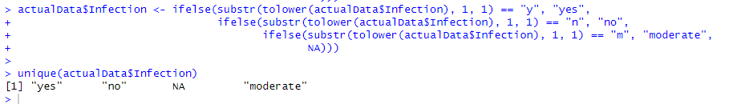

**Description:** Previously some invalid values were found on the Infection attribute. We assumed that if the starting character was y means yes, n means no, m means moderate and ignored further characters of each instance in Infection attribute. And after recovering invalid values, there’s no extra invalid values found using unique() function.

**Annotating Datasets:**

**Code:**

actualData$Infection <- factor(actualData$Infection,

levels = c("yes", "moderate", "no"),

labels = c(1, 0.5, 0))

actualData$RiskLevel <- factor(actualData$RiskLevel,

levels = c("high risk", "low risk", "mid risk"),

labels = c(1, 0, 0.5))

actualData

**Output:**

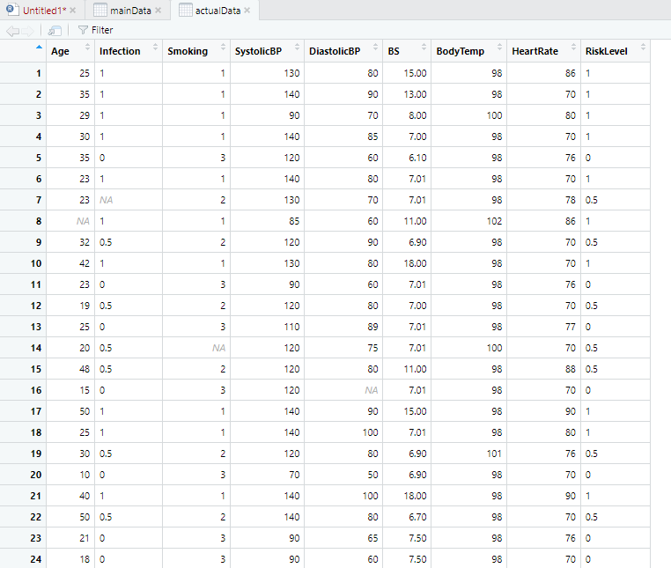

**Description:** The value of these categorical attributes has been converted to numerical values using factor() function.

For Infection attribute: "yes"→1, "moderate"→0.5, "no"→0

For RiskLevel attribute: "high risk"→1, "mid risk"→0.5, "low risk"→0

**Data Statistics:**

**Code:**

summary(actualData)

**Output:**

**Description:** Descriptive Statistics has shown using summary() function. This summary will help on our following works.

**Find Missing Values:**

**Code:**

na_counts <- colSums(is.na(actualData))

print(na_counts)

**Output:**



**Visualize:**

barplot(na_counts, names.arg = names(na_counts),

ylab = "Number of Missing Values", col = "red",

main = "Missing Values per Attribute", las =2)

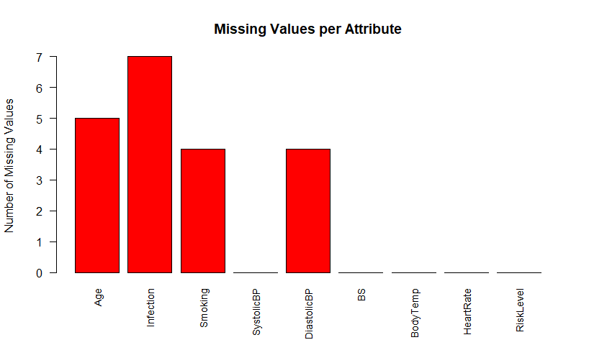

**Description:** Using colSums() and is.na() we found the number of missing values for each attribute. The following missing values were found:

Age: 5

Infection: 7

Smoking: 4

SystolicBP: 0

DiastolicBP: 4

BS: 0

BodyTemp: 0

HeartRate: 0

RiskLevel: 0

# **Handle Missing Values:**

## **1. By Discard Instances:**

**Code:**

cleanData1 <- na.omit(actualData)

na_counts <- colSums(is.na(cleanData1))

print(na_counts)

barplot(na_counts, names.arg = names(na_counts),

ylab = "Number of Missing Values", col = "red",cex.names = 0.9,

main = "Missing Values per Attribute", las =2)

**Output:**

**Description:** All the instances having null values have been removed using na.omit() function.

## **2. Replace by Most Frequent/Average Value**

**Code: (for categorical attribute)**

cleanData2 <- actualData

mode_Infection <- names(sort(table(cleanData2$Infection), decreasing = TRUE))[1]

cleanData2$Infection[is.na(cleanData2$Infection)] <- mode_Infection

mode_RiskLevel <- names(sort(table(cleanData2$RiskLevel), decreasing = TRUE))[1]

cleanData2$RiskLevel[is.na(cleanData2$RiskLevel)] <- mode_RiskLevel

cleanData2

na_counts <- colSums(is.na(cleanData2))

print(na_counts)

barplot(na_counts, names.arg = names(na_counts),

ylab = "Number of Missing Values", col = "red",cex.names = 0.9,

main = "Missing Values per Attribute", las =2)

**Output:**

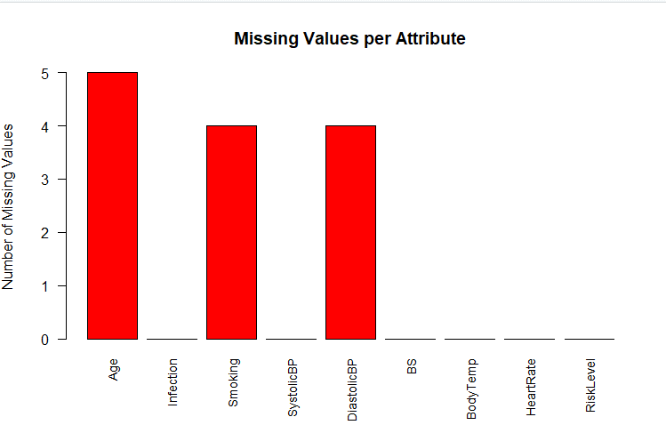

**Description:** After sorting the values of a column, the most frequent value has been found for each column, replaced with missing values of that column.

**Code: (for numerical attribute)**

for(col_name in names(cleanData2)) {

if(is.numeric(cleanData2[[col_name]])) {

column_mean <- mean(cleanData2[[col_name]], na.rm = TRUE)

cleanData2[[col_name]][is.na(cleanData2[[col_name]])] <- column_mean

cleanData2[[col_name]] <- round(cleanData2[[col_name]], digits = 0)

}

}

na_counts <- colSums(is.na(cleanData2))

print(na_counts)

barplot(na_counts, names.arg = names(na_counts),

ylab = "Number of Missing Values", col = "red",cex.names = 0.9,

main = "Missing Values per Attribute", las =2)

**Output:**



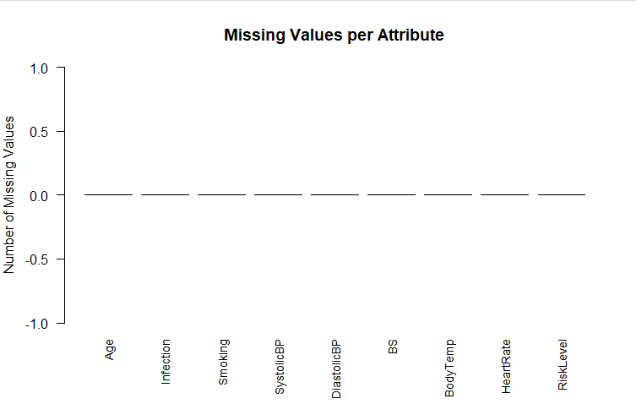

**Description:** After replacing categorical attributes, the estimated values for each row were founded using the average value. Then after rounded the estimated values, the missing values replaced with them.

# **Mean-Median-Mode Graph:**

**Code:**

getMode <- function(v) {

tabulated <- table(v)

mode_value <- names(sort(tabulated, decreasing = TRUE))[1]

return(as.numeric(mode_value))

}

means <- sapply(cleanData2, function(x) if(is.numeric(x)) mean(x, na.rm = TRUE) else NA)

medians <- sapply(cleanData2, function(x) if(is.numeric(x)) median(x, na.rm = TRUE) else NA)

modes <- sapply(cleanData2, function(x) if(is.numeric(x) || is.factor(x) || is.character(x)) getMode(x) else NA)

stat_values <- rbind(means, medians, modes)

row_names <- c("Mean", "Median", "Mode")

rownames(stat_values) <- row_names

barplot(stat_values, beside = TRUE,

col = c("green", "orange", "brown"),

legend.text = row_names, args.legend = list(x = "topright", cex = 0.7),

cex.names = 0.7)

**Output:**

**Description:** Initially mean, mode and were found using sapply() function, then the values were combined in stat_values matrix using rblind(). A Barplot has been drawn to visualize.

# **Find Outliers:**

**Code:**

boxplot(cleanData2$Age, main = "Age")

boxplot(cleanData2$Smoking, main = "Smoking" )

boxplot(cleanData2$SystolicBP, main = "SystolicBP" )

boxplot(cleanData2$DiastolicBP, main = "DiastolicBP" )

boxplot(cleanData2$BS, main = "BS")

boxplot(cleanData2$BodyTemp, main = "BodyTemp" )

boxplot(cleanData2$HeartRate, main = "HeartRate" )

**Output:**

**

**

**Description:** Using boxplot, we found outliers on Age, BS, BodyTemp

# **Removing Outliers:**

**Code:**

age_mean <- round(mean(cleanData2$Age, na.rm = TRUE))

age_outliers <- boxplot.stats(cleanData2$Age)$out

age_outliers

cleanData2$Age[cleanData2$Age %in% age_outliers] <- age_mean

boxplot(cleanData2$Age, main = "Age")

age_outliers

bs_mean <- round(mean(cleanData2$BS, na.rm = TRUE))

bs_outliers <- boxplot.stats(cleanData2$BS)$out

bs_outliers

cleanData2$BS[cleanData2$BS %in% bs_outliers] <- bs_mean

boxplot(cleanData2$BS, main = "BS")

bodytemp_mean <- round(mean(cleanData2$BodyTemp, na.rm = TRUE))

bodytemp_outliers <- boxplot.stats(cleanData2$BodyTemp)$out

bodytemp_outliers

table(cleanData2$BodyTemp)

bodytemp_outliers <- bodytemp_outliers[bodytemp_outliers < 0]

bodytemp_outliers

cleanData2$BodyTemp[cleanData2$BodyTemp %in% bodytemp_outliers] <- bodytemp_mean

boxplot(cleanData2$BodyTemp, main = "BodyTemp" )

table(cleanData2$BodyTemp)

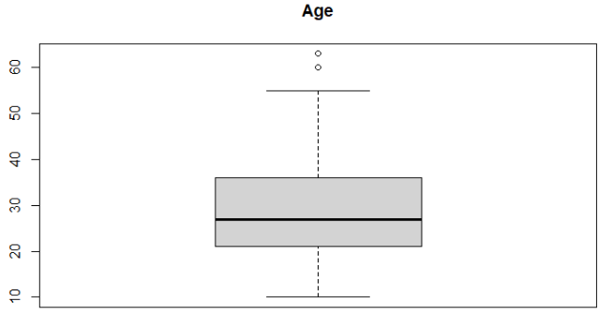**Output:**

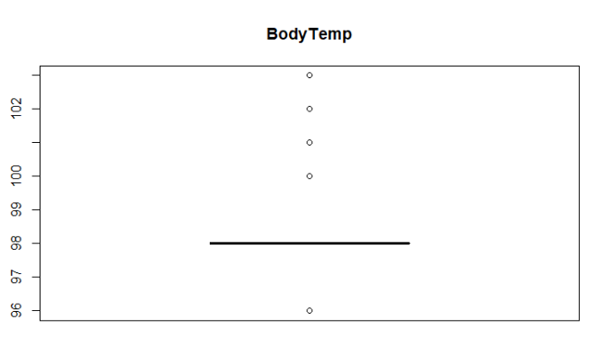

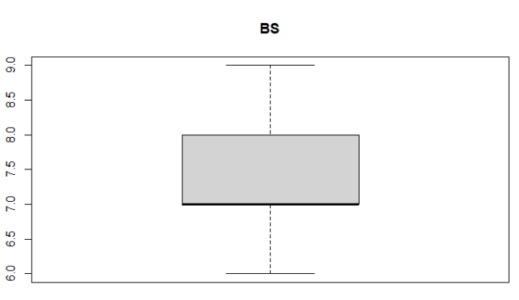

**Description:** The outliers of Age attribute were removed from Age, but while plotting box plot, we found that some new outliers appeared. We ignored them because the values are so near to our data. After converting outliers of BS using mean value, there no outlier remains.

In BodyTemp attribute, we removed negative outliers first, then after considering value counts of the rest values of bodytemp_outlier , all other values are valid. So, we shouldn’t remove them.

# **Normalize SystolicBP:**

**cleanData2 table:**

**Code:**

min_SystolicBP <- min(cleanData2$SystolicBP, na.rm = TRUE)

max_SystolicBP <- max(cleanData2$SystolicBP, na.rm = TRUE)

cleanData2$SystolicBP <- (cleanData2$SystolicBP - min_SystolicBP) / (max_SystolicBP - min_SystolicBP)

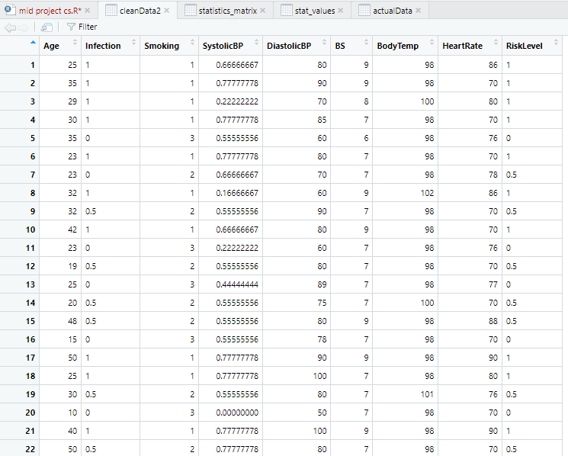**Output:**

**Description:** Normalized using Xnew=(X-Xmin)/(Xmax-Xmin)

# **Convert Numerical Attributes to Categorical:**

**Code:**

outputData<- cleanData2

outputData$Infection <- factor(outputData$Infection,

levels = c(1, 0.5, 0),

labels = c("yes", "moderate", "no"))

outputData$RiskLevel <- factor(outputData$RiskLevel,

labels = c("high risk", "low risk", "mid risk"),

levels = c(1, 0, 0.5))

outputData$Smoking <- factor(outputData$Smoking,

labels = c("yes", "sometimes", "no"),

levels = c(1, 2, 3))

outputData

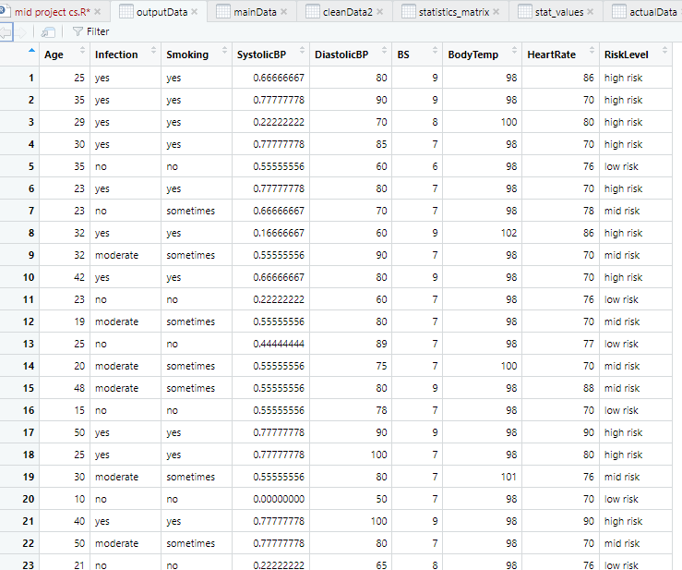**Output:**

**Description:** Three categorical attributes shown using factor() function.